ASSIGNMENT – 10 (DBMS LAB)

* **PROBLEM:**

Consider the following schema of project database

PROJECT (proj_id, proj_name, project_manager_id) EMPLOYEE (emp id, emp_name, age, joining_date) ASSIGNED (proj_id, emp id)

Provide SQL statements for the following queries:

1. Obtain details of employees working on the project named SYSTEM.

2. Get details of employees working on both projects P200 and P300.

3. Find the employee ids who are working on all projects.

4. Find the employee ids who are assigned to only one project.

5. Find the employee ids who are assigned to more than one project.

6.Find the project ids which have the maximum & minimum no of employees assigned.

7. Find the project ids which has the highest average age of employees assigned.

8. Find the project manager who has the maximum no of projects.

* **PROGRAM:**

create table project(proj_id varchar2(38),proj_name varchar2(38),proj_manager_id varchar2(38),primary key(proj_id));

* **OUTPUT:**

Table created.

* **PROGRAM:**

describe project;

* **OUTPUT:**

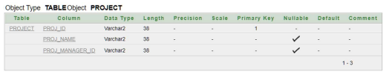

* **PROGRAM:**

create table employee(emp_id varchar2(38),emp_name varchar2(38),age number(38),joining_date date,primary key(emp_id));

* **OUTPUT:**

Table created.

* **PROGRAM:**

describe project;

* **OUTPUT:**

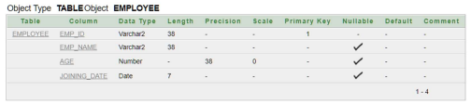

* **PROGRAM:**

create table assigned(proj_id varchar2(38),emp_id varchar2(38),foreign key(proj_id) references project(proj_id),foreign key(emp_id) references employee(emp_id));

* **OUTPUT:**

Table created.

* **PROGRAM:**

describe project;

* **OUTPUT:**

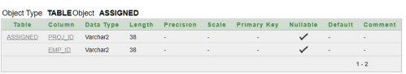

* **PROGRAM:**

BEGIN  
insert into project values('P200','SYSTEM5','PM200');  
insert into project values('P201','PSE3','PM201');  
insert into project values('P203','PABC','PM203');  
insert into project values('P204','PDEF','PM204');  
insert into project values('P205','SYSTEM','PM205');  
insert into project values('P206','PXYZ','PM206');  
insert into project values('P207','PMNP','PM207');  
insert into project values('P208','PORS','PM208');  
insert into project values('P209','PMAH','PM209');  
insert into project values('P210','PBCD','PM210');  
insert into project values('P211','PDEG','PM211');  
insert into project values('P212','PEGA','PM212');  
insert into project values('P213','PSYSP','PM213');  
insert into project values('P214','PAZC','PM214');  
insert into project values('P300','PAKZ','PM300');  
END

* **OUTPUT:**

Statement processed.

* **PROGRAM:**

select * from project;

* **OUTPUT:**

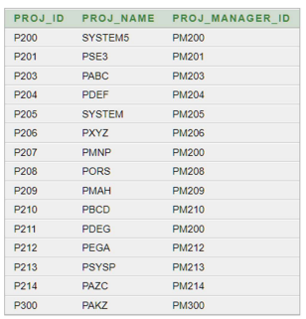

* **PROGRAM:**

BEGIN  
insert into employe values('E101','Suraj Kumar Das','32','02-NOV-1999');  
insert into employe values('E102','Koushik Jana','33','03-DEC-1998');  
insert into employe values('E103','Sitangshu Roy','31','10-NOV-1997');  
insert into employe values('E104','Rohit Singh','34','28-DEC-1995');  
insert into employe values('E105','Mala Sen','30','28-DEC-2021');  
insert into employe values('E106','Ripon Sur','31','22-DEC-2020');  
insert into employe values('E107','Sayan Sen','32','12-AUG-2019');  
insert into employe values('E108','Nitesh Singh','30','13-OCT-2019');  
insert into employe values('E109','Manimala Dutta','34','14-AUG-2018');  
insert into employe values('E110','Krishna Dasgupta','33','23-OCT-1996');  
insert into employe values('E111','Liton Pal','32','24-NOV-1995');  
insert into employe values('E112','Gourab Das','35','21-JUL-1996');  
insert into employe values('E113','Sabuj Pal','34','12-SEP-1995');  
insert into employe values('E114','Mrinal Sen','33','12-AUG-2012');  
insert into employe values('E115','Sathi Barma3','32','11-JAN-2019');  
END

* Top of Form
* Bottom of Form
* **OUTPUT:** .

Statement processed.

* **PROGRAM:**

select * from employee;

* **OUTPUT:** .

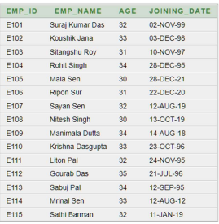

* **PROGRAM:**

begin

insert into assigned values('P200','E101');

insert into assigned values('P200','E102');

insert into assigned values('P201','E101');

insert into assigned values('P201','E107');

insert into assigned values('P203','E101');

insert into assigned values('P203','E108');

insert into assigned values('P204','E101');

insert into assigned values('P204','E109');

insert into assigned values('P205','E101');

insert into assigned values('P205','E104');

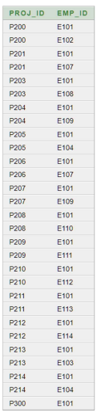insert into assigned values('P206','E101');

insert into assigned values('P206','E107');

insert into assigned values('P207','E101');

insert into assigned values('P207','E109');

insert into assigned values('P208','E101');

insert into assigned values('P208','E110');

insert into assigned values('P209','E101');

insert into assigned values('P209','E111');

insert into assigned values('P210','E101');

insert into assigned values('P210','E112');

insert into assigned values('P211','E101');

insert into assigned values('P211','E113');

insert into assigned values('P212','E101');

insert into assigned values('P212','E114');

insert into assigned values('P213','E101');

insert into assigned values('P213','E103');

insert into assigned values('P214','E101');

insert into assigned values('P214','E104');

insert into assigned values('P300','E101');

end

* **OUTPUT:** .

Statement processed.

* **PROGRAM:**

select * from assigned;

* **OUTPUT:** .
* **PROGRAM:**

select * from employee where emp_id in(select emp_id from assigned where proj_id=(select proj_id from project where proj_name='SYSTEM'));

* **OUTPUT:** .



* **PROGRAM:**

select * from employee where emp_id in(select emp_id from assigned where proj_id='P200' and emp_id in(select emp_id from assigned where proj_id='P300'));

* **OUTPUT:** .



* **PROGRAM:**

select emp_id,count(proj_id) as no_of_project from assigned group by emp_id having count(proj_id)=(select count(proj_id) from project);

* **OUTPUT:** .



* **PROGRAM:**

select emp_id from assigned GROUP BY emp_id having count(proj_id)=1;

* **OUTPUT:** .



* **PROGRAM:**

select emp_id from assigned GROUP BY emp_id having count(proj_id)>1;

* **OUTPUT:** .

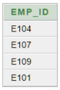

* **PROGRAM:**

select proj_id,count(*) as no_of_employees from employee join assigned on employee.emp_id=assigned.emp_id group by proj_id order by count(*) desc;

* **OUTPUT:** .

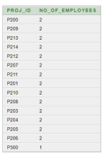

* **PROGRAM:**

select proj_manager_id,count(*) as maximam_no_of_project from project group by proj_manager_id having count(proj_id)>1;

* **OUTPUT:** .

